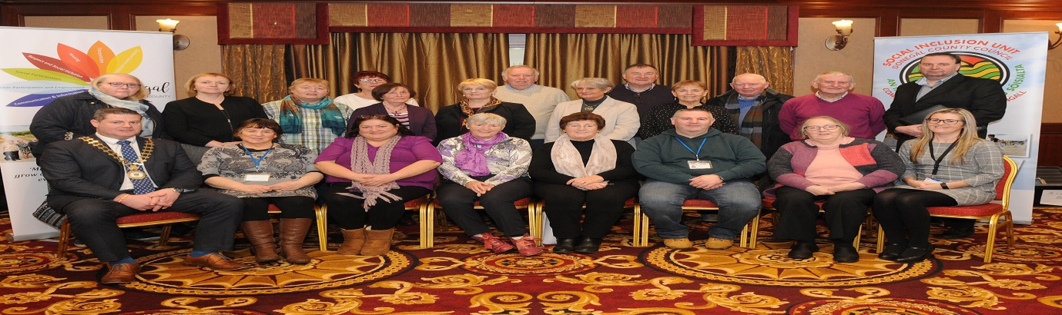
OLDER PERSONS COUNCIL ANNUAL GENERAL MEETING
The Older Persons Council held their AGM on Wednesday, January 23, 2019 in the Mount Errigal Hotel at 11am. Despite the weather warning there was great attendance from Older Peoples Groups from all over Donegal.
The AGM was opened by the Cathaoirleach Cllr Seamus O’Donnell, who spoke about the positive work being carried out by the Older Persons Council Donegal. He went on to talk about Donegal’s aging population and how important it is for agencies to continue to work together in making Donegal a better place to grow old in.
Seamus Neely, Chief Executive of Donegal County Council and Chair of the Age Friendly Alliance spoke about the Donegal Age friendly Programme, that 3 year Age Friendly Strategy is currently being reviewed with the hope of launching it in the coming weeks.
Some of the projects he mentioned that were carried out were, the walkability audit in Letterkenny University Hospital, where new signage and the first Age Friendly Car Parking was installed. Letterkenny Town was the first age friendly town in Donegal with the role of the Business recognition training to all businesses. This is hoped to be extended across other towns within the county. Mr Neely mentioned that Age friendly training was provided to frontline staff in Donegal County Council and that the council launched an Older Persons information guide which was available to the people on the day.
Mr Neely spoke of the excellent work carried out by SITT. The Local Link bus has provided additional bus routes and services for Older People in the rural areas which allows them to get out of the house, and also the Donegal Age Friendly Programme, which is implanting real change in an imaginative and cost-effective way.

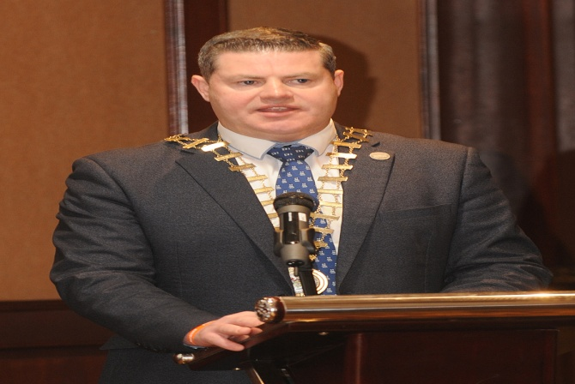
Seamus Neely expressed that his role on the Age Friendly Alliance group is one he enjoys. It is very positive work and it’s something in the long run that everyone will benefit from through their journey growing old in Donegal. Mr Neely commended on the work carried out by the Older Persons Council especially joint Chair Gráinne Hines and Mary McGowan and finished off by thanking Charles Sweeney and Mairead Cranley, Donegal County Council for their work in implementing the Age friendly Programme in Donegal.
Reports were then presented by Joint Chairs Gráinne Hines and Mary McGowan explaining some of the projects carried out by the Older Persons Council. This included Intergenerational projects, engagement with the Health services for Older People and installation of Gym Equipment in Letterkenny Town Park. Ms Hines spoke about importance for Older People to come forward to have their voice heard, and not to be afraid of joining the Older Persons Council. Special guest Fergus Cleary also spoke and told jokes of his journey through life and what it’s like to grow old.
New members were elected to the Older Persons Council executive committee. The committee represent all different types of Older People’s Groups, Advocacy Groups, Younger Older People, Frail Older People, people that represents the voice for older people in Residential Homes or older people’s services in Donegal.

